# TOPIC: AppiumLibrary interact with WPF default Controls

## Research Items

|  |  |  |  |
| --- | --- | --- | --- |
| **No** | **Item Details** | **Status** | **URL** |
| 1 | Create another WPF application contains some common controls, also another Windows | Done | <https://github.com/mtran21081990/WinAppAutomation/tree/master/SampleApplication/Restaurant_Order_Application> |
| 2 | Create a test suite to run automation on 2nd sample WPF application | Done | <https://github.com/mtran21081990/WinAppAutomation/tree/master/SampleProjects/AppiumLibraryAutomation> |
| 3 | Run test suite and report result | Done |  |

## Research Details

*1. 2nd Sample WPF application*

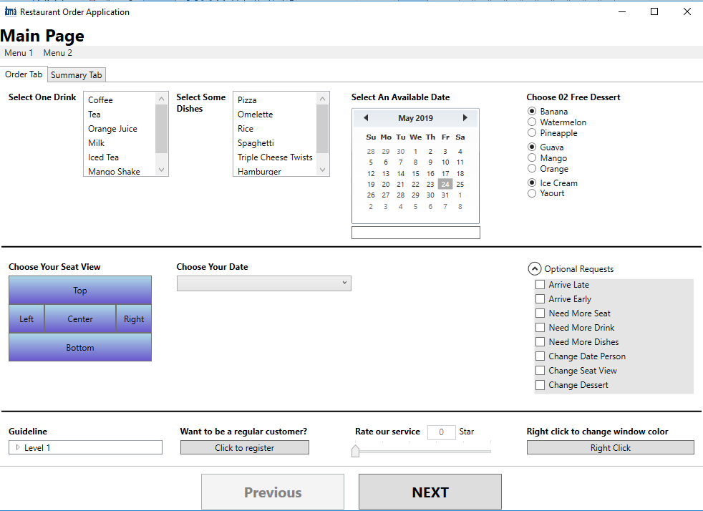

Click **Next** Button to open 2nd Window.

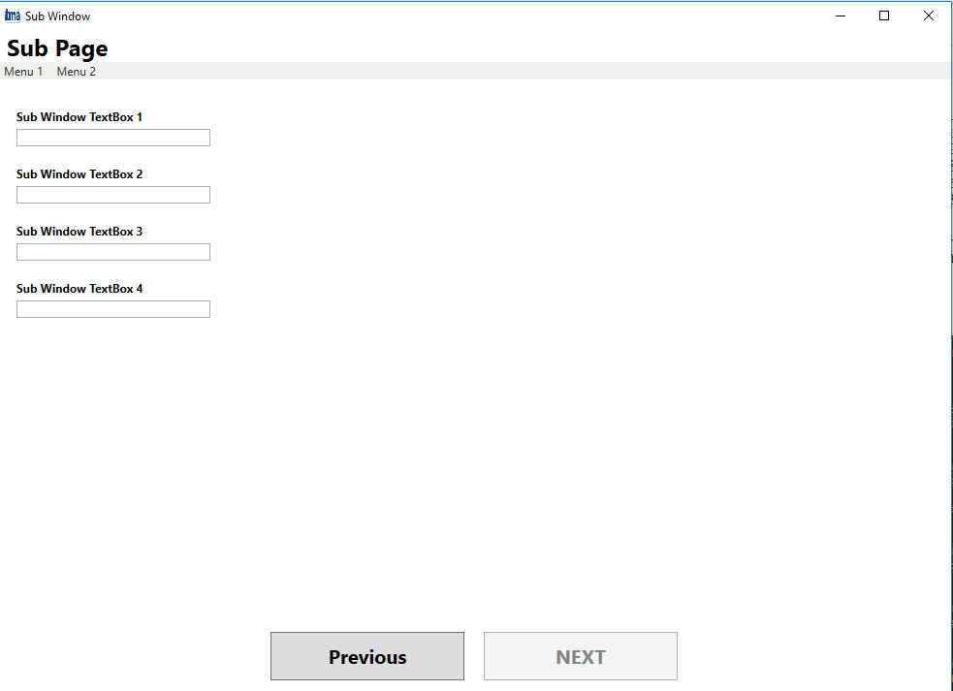

All controls are specified with unique Name attributes.

*2. Sample Test Suite*

**Suite 1**: Interact with some controls on Main Window

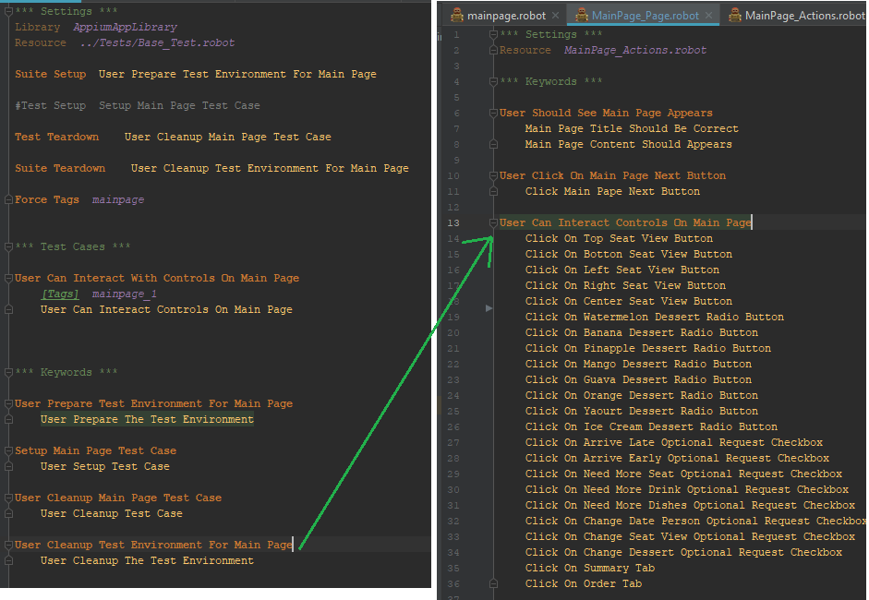

**Suite 2**: Open Main Window, Click Next button to switch to 2nd Window, interact with controls on 2nd Window.

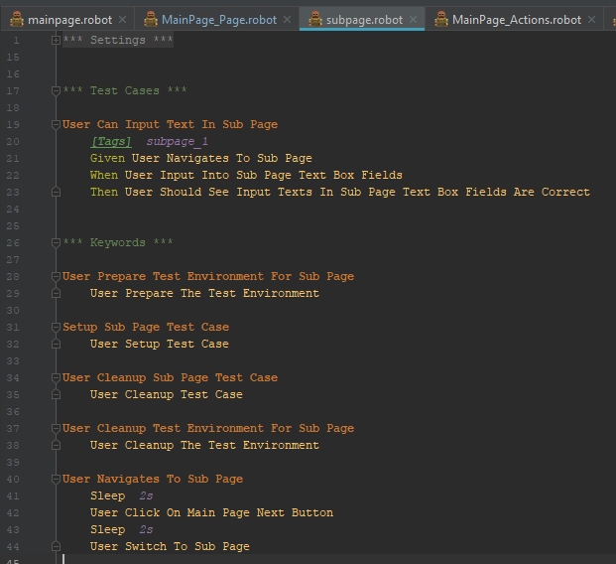

*3. Test Results*

1. By default, AppiumLibrary can only interact with action Click or Input (e.g.: Button, TextBox, CheckBox…) 🡪 Need to customize keywords to handle other controls (Combobox, Slider, Table…): **NOT YET**

2. By default, AppiumLibrary only provide mechanism to switch between already-opened applications IF they are opened by Appium itself (Appium mechanism: when it opens an application, it will register that app into its caches for later reuse).

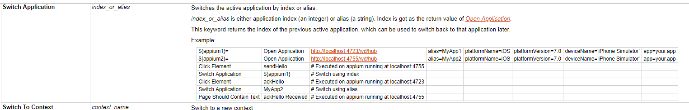

If a window is opened by running test (e.g.: click a button & a Window is opened), it cannot be switched using default “Switch Application” keyword.

🡺 A new keyword is needed: **DONE**.

**Main idea**: Before register & open the Main window, use Appium to register the DESKTOP app (a.k.a: Root app).

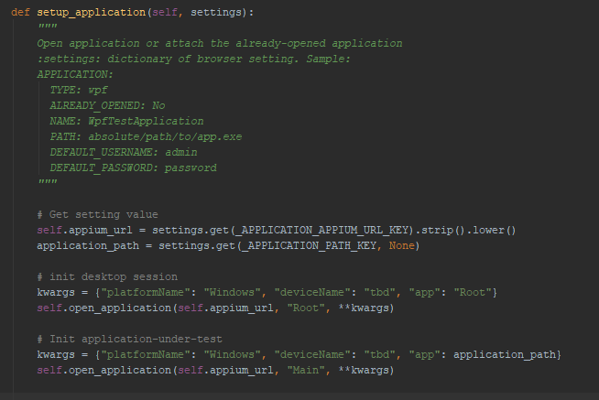

When a new window is opened, that window need to be registered by Appium:

1. Switch back to Desktop app.
2. Find the new Window with any unique locator (AutomationId, Title…)
3. Get the window’s attribute “*NativeWindowHandle”*.
4. Use appium to open that window with new capability “appTopLevelWindow”

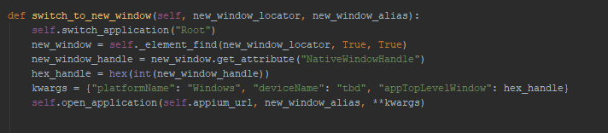

* **Current ISSUE**: The newly opened window can be interact, but only after a period (in 60 sec). Appium, for some reasons, have to expire current session and start a new one to find the new window attribute. This will happen again if new Window is opened.